Match3 evolution

## Core functionality

* Standard match3, combination has been calculated after falling all of tiles.

## Motivation and progress.

Game progress follows steps of evolution in 3 epoches.

Kind of progress.:

* Get higher evolution level to evolve animals.
* Get more score to evolved animals.
* There is secondary evolution chain.
* Collect DNA samples to excelerate secondary evolution.
* Collect treasures for more scores.
* Dig to end of stages. Each of them are 1000 tiles long to down.

## Evolution types

### Shape evolution:

Add marker top UI to show number of necessary elements to collect to evolve animal to next level.

Show evolution chain of UI.

Secondary evolution is available on latest evolution level. Secondary level collected from neighbors of matched elements as high level animals eats them.

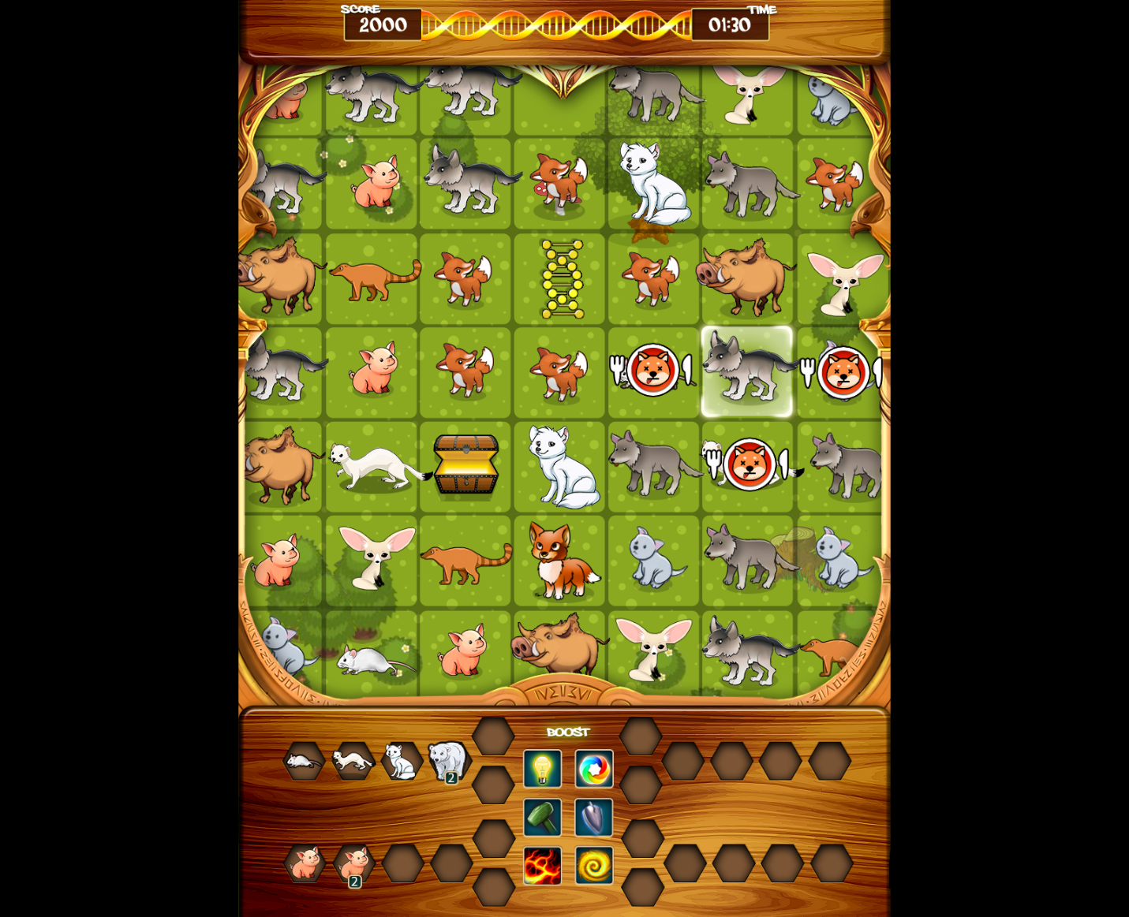

### DNA samples

There are collectable DNA sample tiles, that fills up DNA mutant meter at top of UI.

If an animal reaches top level of evolution and DNA is full, evolution level will automatically switch t o second level, and clean DNA meter.

## Shape 2x2 as Secondary evolution level

At end of evolution chain, there are 2 available animals. When second has been achieved, those animals fill 2x2 tiles. It behaves similarly than normal, but falling only when there are 2 spaces under it. Matching when 2x2 tiles are in full overlap on any sides.

Top animals(2x2) eating its neighbor at matching.

## Scroll

Bottom 2 lines of stages have been locked with animals from higher evolution level.

To unlock it player needs to evolve animals to this level, and remove bottom lines with matching. That will unlock deeper part of stages (represents dig down into geological layers).

Reference game.: Bejeweled3

## Levels

Game mechanic is same on all Level, but levels have different artwork, and animals.

### Ocean:

Represent early oceanic life on earth. Start from volcanic surface into the ocean, including corals, and plants at and of level.

Portrait lobby screen 1080x1920

Background is portrait 1080x19200 as scrolling

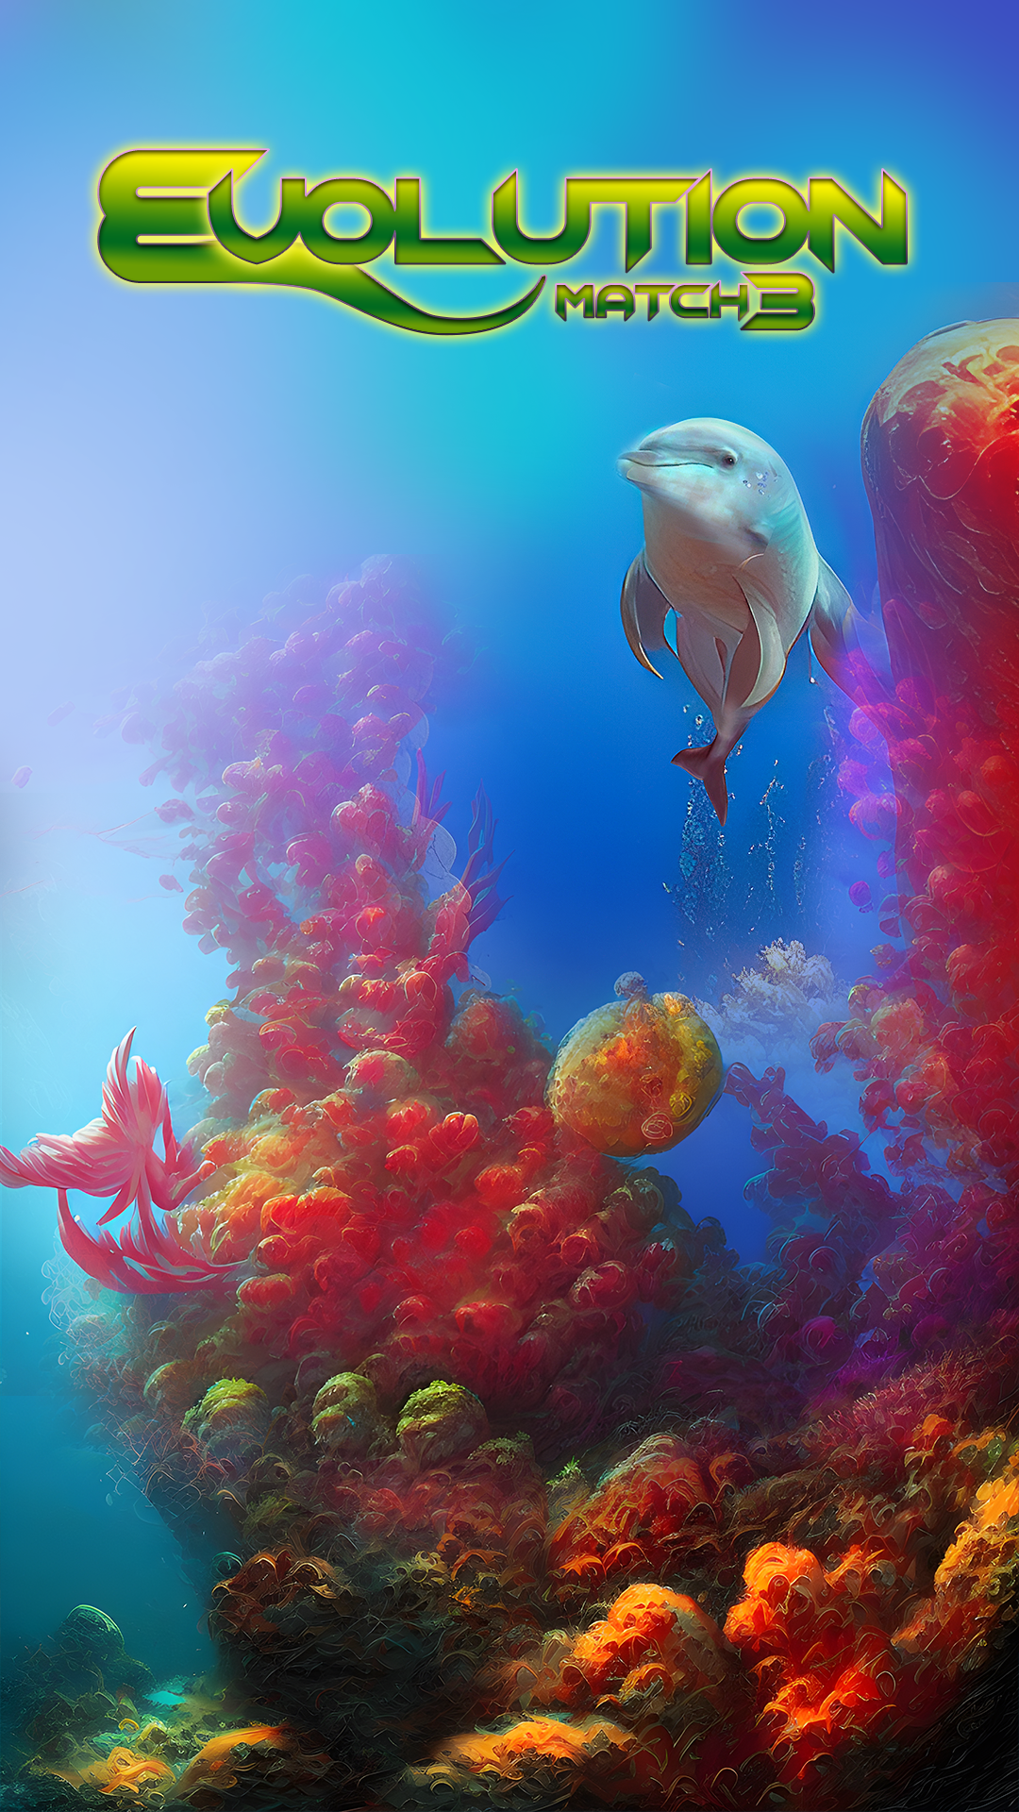

#### Bonus items.:

* Whale skeleton (tile size is 2x2)
* Gold chunk
* Diamond

#### Animals (animated in 12 frames)

- Amoeba

- Trilobite

- Sea star

- Anemonefish

- Crocodile 2x2

- Whale 2x2

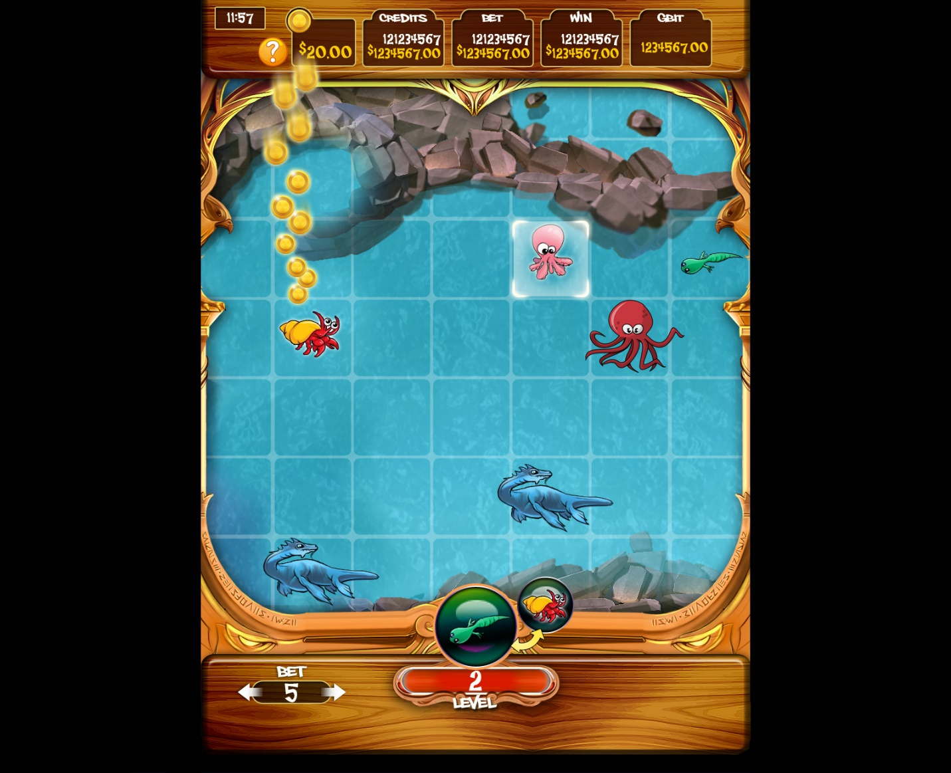

### Dinoworld

From volcanic shores to jungle.

Portrait lobby screen 1080x1920

Background is portrait 1080x19200 as scrolling

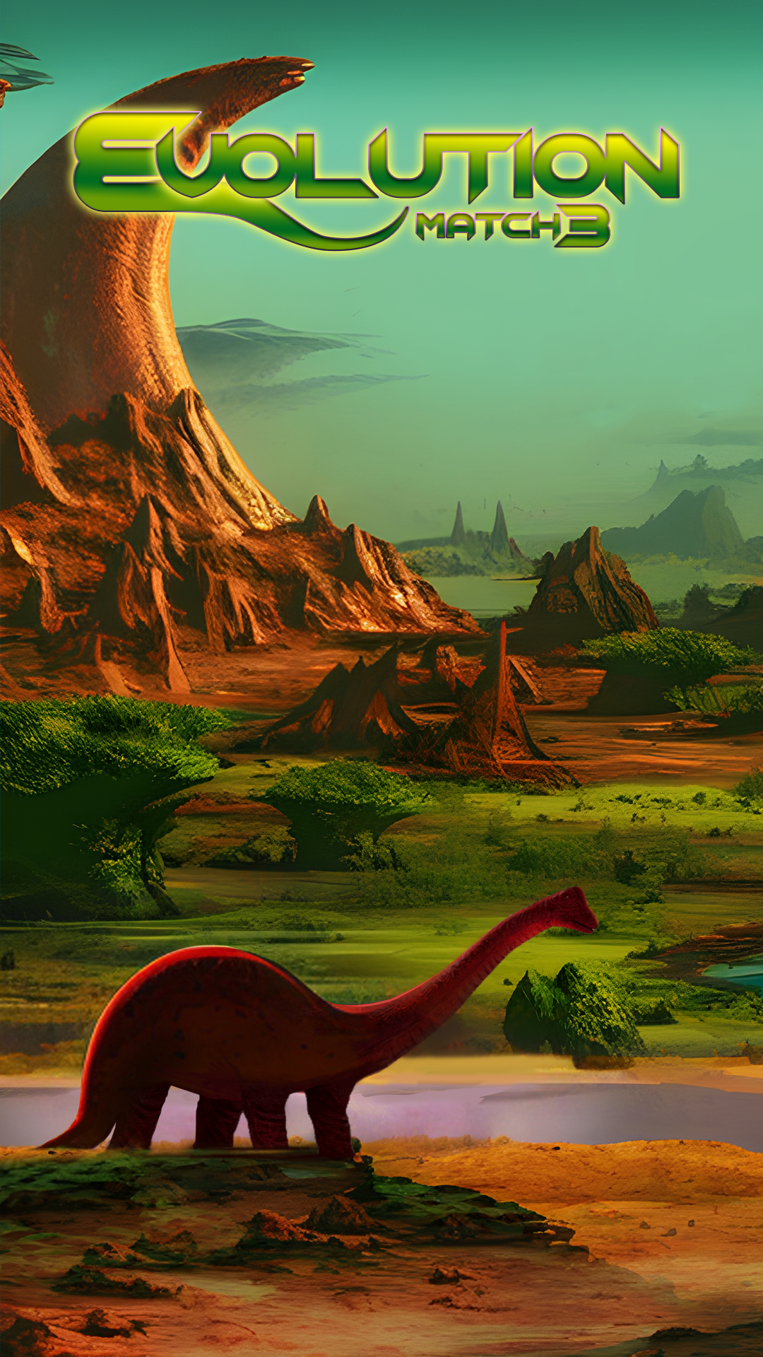

#### Bonus items.:

* Dino skeleton (2x2)
* UFO
* Ruby

#### Animals:

- Turtle

- Stegosaurus

- Sauropoda

- Ceratopsian

- King penguin 2x2

- Tyrannosaurus 2x2

### Forest

From rainforest to mammoth trees.

Portrait lobby screen 1080x1920

Background is portrait 1080x19200 as scrolling

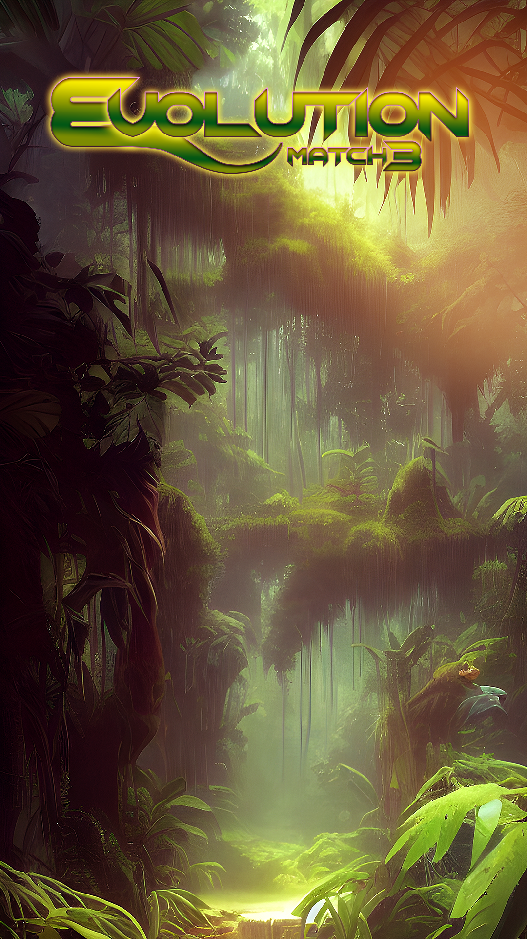

#### Bonus items.:

* Mammoth tusk
* Treasure chest
* Sapphire

#### Animals:

- Mouse

- Stoat

- Desert fox

- Fox mini

- Wolf 2x2

- Boar 2x2

## Achievement

Evolve all animals.

Collect 100 animals from all.

Collect 1000 animals from all.

Collect 1000 animals from all.

1000 match

10000 match

100000 match

1000000 match

Match more than 4 tiles 100x

Match more than 4 tiles 10x0x

10,20-100levels

by achievements

## Leaderboard

* leaderboard by score
* number of matches x level of matched animal

## Effect at match.

Take effect when match happens.

* Any 2x2 counts one
* Match 4 tiles: gives joker tile (match with any animals)
* Match 5 tiles: create a lightening bolt in direction of match.
* Match 6 tiles: Color frenzy (remove same tiles from stage)
* 7 or more: lightening bolt in every direction from every titles (based of effect to match 5)

## Boost

Player get a random boost overt match 4.:

5 = 1

6 = 2

>7 = 3

Boost types.:

* Hint: Show best match.
* Color frenzy: Remove selected animal.
* Hammer: Wipe out an animal.
* Spade: Remove a row except bottom line.
* Extinction: Burn out selected animals and its neighbors.
* Spiral: Remove tiles from spiral spline.

Every boost has it fill up timer. It takes 30 sec to reload a boost, and available to retrigger again.

### **Scoring / Win Conditions**

### The player who earns the most points will win each match. Below is a list of all the game actions that award points. The actual point values should be parameterized. (Refer to the “Game Parameters” section for further details.) The score values below are just examples.

### ● Matching animals ​ -- 10 points per animal * evolution level

### ● Evolution achieved​ -- 200

### ● Reach second branch of evolution line -- 1000 points (as there is a fork in the line)

### ● Treasure​ – 1000 points